**ASSIGNMENT 2**

**CASE 9:**

SELECT emp_id,

Salary,

commission FROM globetechtb231;

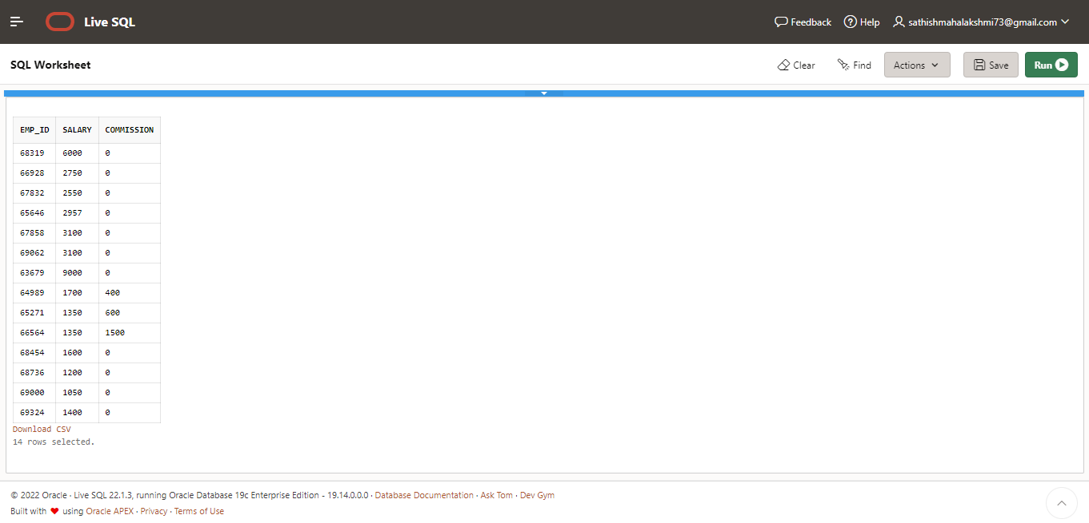

**CASE 10:**

SELECT DISTINCT dep_id,

job_name FROM globetechtb231 ;

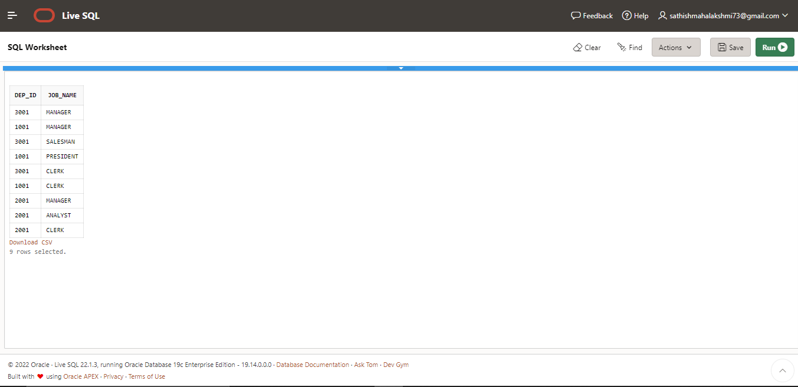

**CASE 11:**

SELECT * FROM globetechtb231

WHERE dep_id NOT IN (2001);

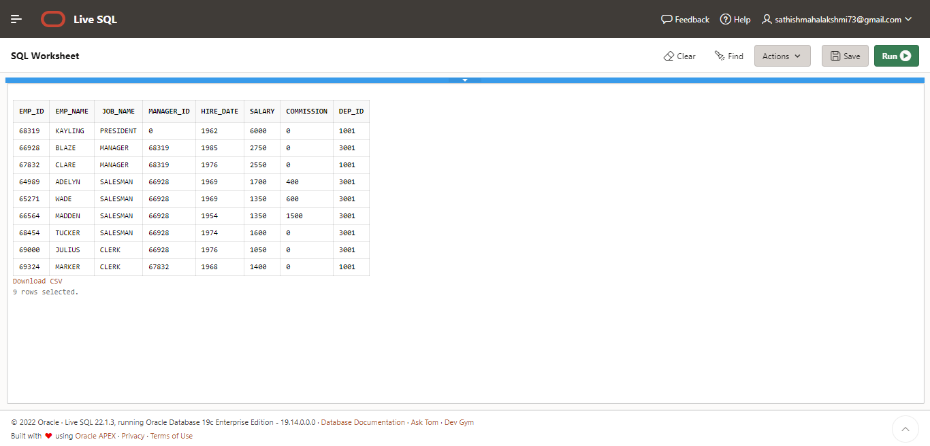

**CASE 12:**

SELECT * FROM globetechtb231

WHERE hire_date<to_date(('1991-1-1'),'yyyy-mm-dd');

**CASE 13:**

SELECT avg(salary) FROM globetechtb231

WHERE job_name = 'ANALYST; 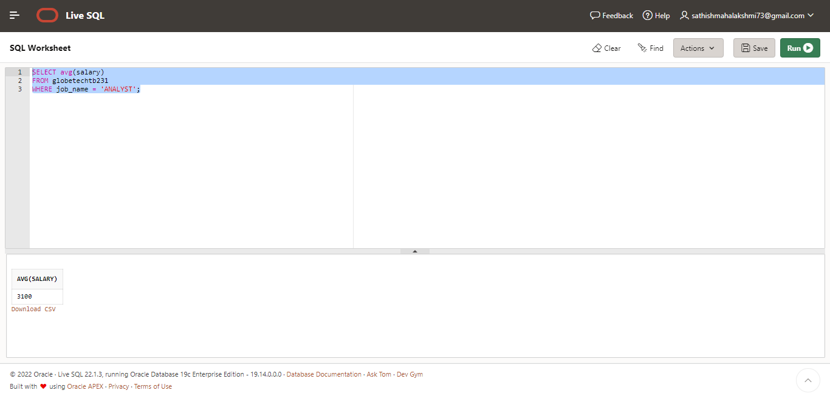

**CASE 14:**

SELECT * FROM globetechtb231

WHERE emp_name = 'BLAZE'; 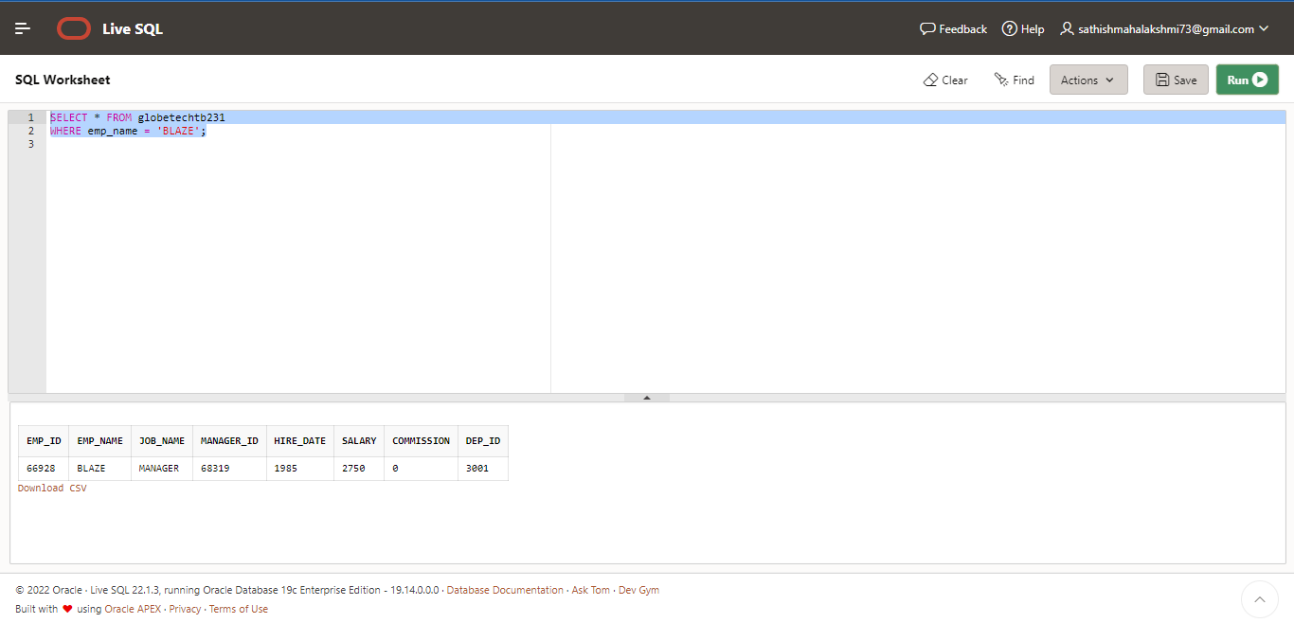

**CASE 15:**

SELECT * FROM globetechtb231

WHERE commission>salary; 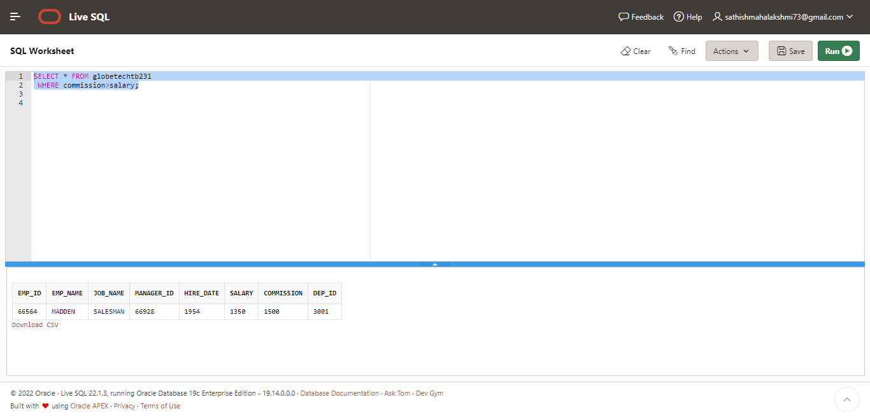

**CASE 16:**

SELECT * FROM globetechtb231

WHERE (1.25*salary) > 3000; 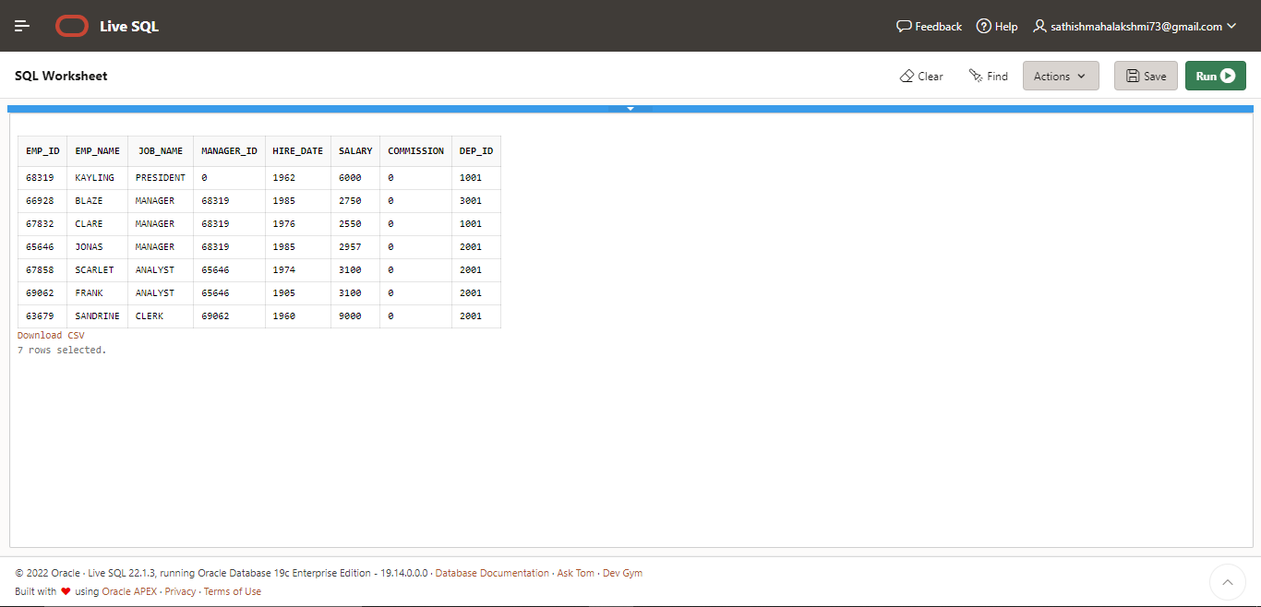

**CASE 17:**

SELECT emp_name

FROM globetechtb231

WHERE length(emp_name)=6; 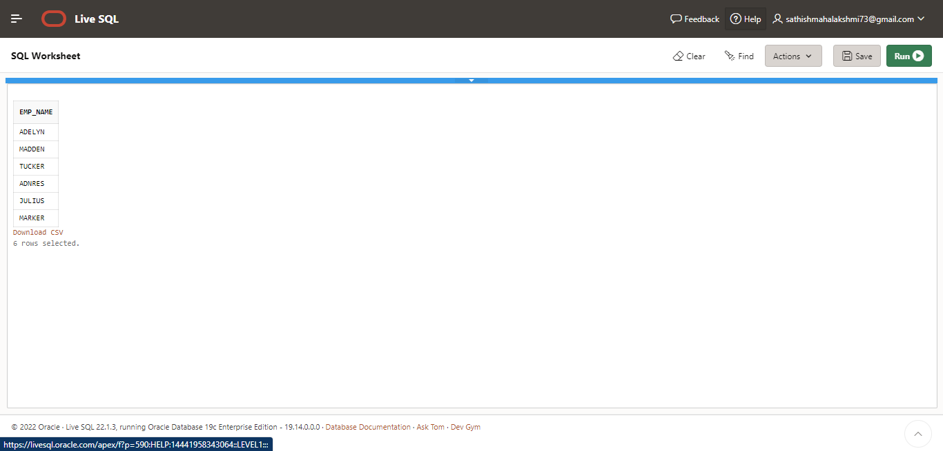

**CASE 18:**

SELECT * FROM globetechtb231

WHERE to_char(hire_date, 'mon')='jan';

**CASE 19:**

SELECT e.emp_name || ' works for ' || m.emp_name FROM

globetechtb231 e,

globetechtb231 m

WHERE e.manager_id = m.emp_id;

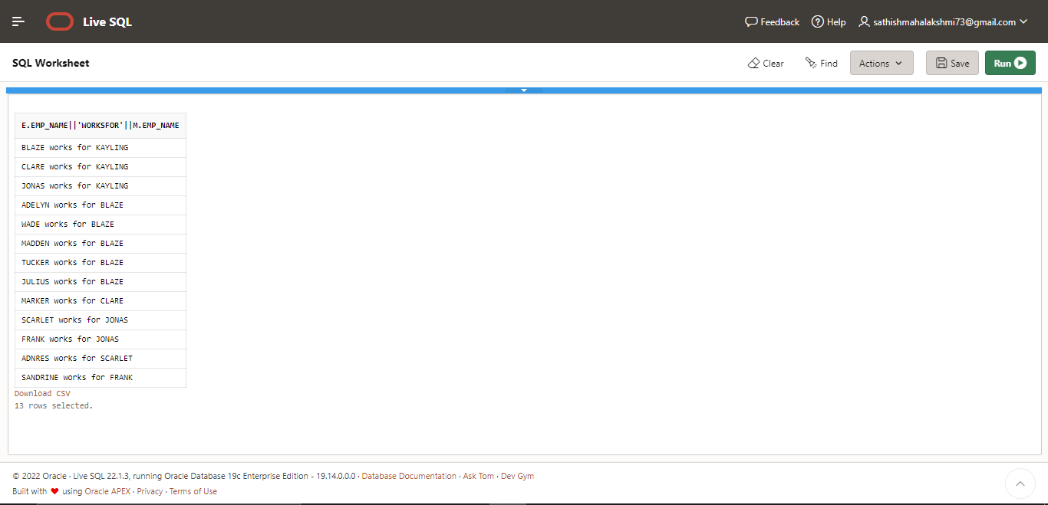

**CASE 20:**

SELECT * FROM globetechtb231

WHERE job_name = 'CLERK'; 